Nandida Valsaraj

1. 
2. [info@libreriacies.es](mailto:info@libreriacies.es)

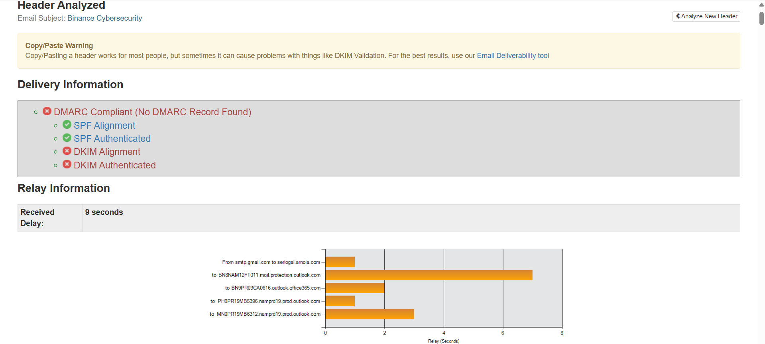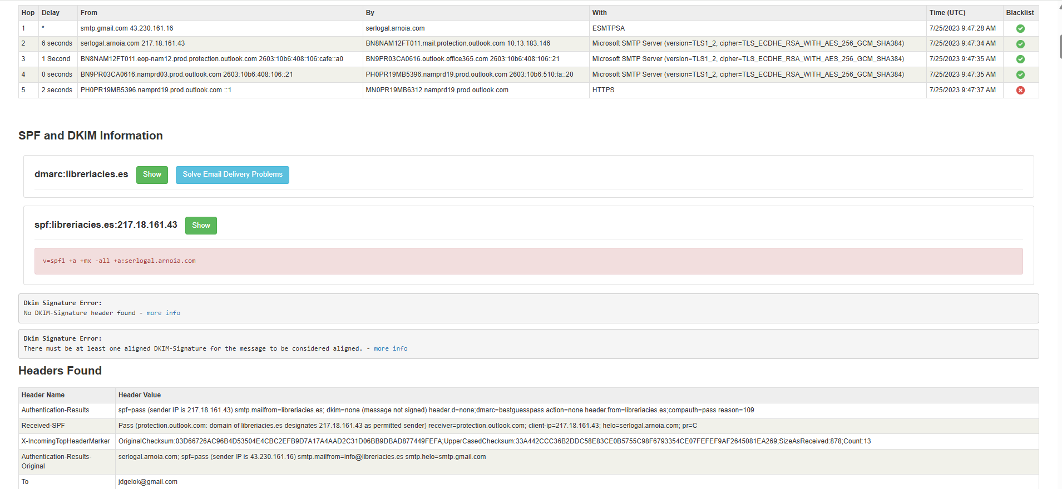

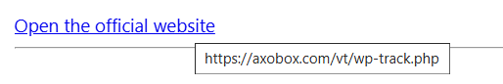

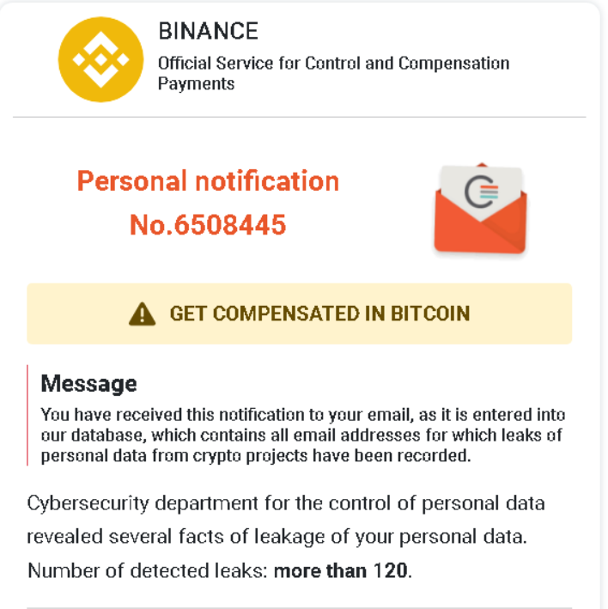

Email address has been leaked is the urgent/threatening language





No spelling errors

* Spoofed email address
* Suspicious link
* Urgent language